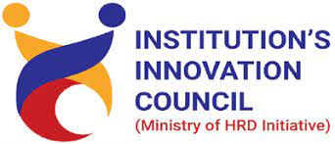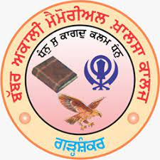

BABBAR AKALI MEMORIAL KHALSA COLLEGE

GARHSHANKAR

Exhibition/Poster Presentation of Ideas

On
National Mathematics Day
22nd December, 2022

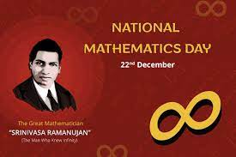

To celebrate the birth anniversary of India's famed mathematician Srinivasa Ramanujan and his contributions to number theory, infinite series, mathematical analysis, etc.
Mathematics Department together with IIC is organising an event of Exhibition/Poster Presentation of Ideas to mark to celebrate his works and recognize him as a legend in mathematics.

- Present your Ideas through Exhibition/presentation/Visual Demonstration.
- Certificates/Prizes will be given.

Mentors (Innovation Ambassadors) Organising Team

Dr. Kuldeep Kaur
Mathematics Department
Prof Jaswinder Kaur

Department of Mathematics

With IIC

(B.A.M. Khalsa College Garhshankar)

Exhibition/Poster Presentation of Ideas

On
National Mathematics Day
22nd December, 2022

Present your Ideas through Exhibition/presentation/Visual Demonstration.

On the themes
- Entrepreneurship for mathematicians

- The role of mathematicians in innovation

- Solving real world problems

- Working as a mathematician in industry

- Skills and opportunities

- Applications of your research

- How to translate your research into an innovative solution.

Mentors (Innovation Ambassadors) Organising Team

Dr. Kuldeep Kaur Mathematics Department
Prof Jaswinder Kaur

